**Assignment 1**

**Description:**

1. Assume that you have the following JavaScript code:

Code –

const user = 'iiht_code';

const attempts = 5;

console.log('%s failed to login %i times', user, attempts);

let’s format a message containing a string and an integer

**Show the output.**

1. **Get the console log output?**

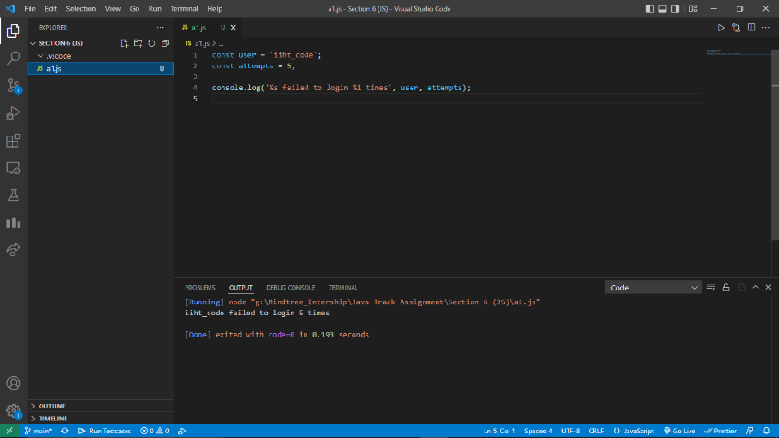

1. **Using const can we define a variable in above code or not.**

**YES**

1. **%s and %i are replaced with values of user and attempts. The specifier %s is converted to a __iiht_code_, while %i is converted to a ____5________.**

**Output:**

**Performance Outcomes:**

Upon successful completion of the assignment, the participant is well versed in

1. User are able to create const and use with log function and find the appropriate result.
2. Knowledge to maintain the output value using log based on string and int.
3. Able to know how can assign and get variable value print single line.